What is CIDR?
CIDR stands for Classless Inter-Domain Routing. It's a way to represent IP address ranges more flexibly using:
css
IP address / Subnet mask
🧠 Example:
CopyEdit
192.168.1.0/24
This means:
- IP range from 192.168.1.0 to 192.168.1.255
- Total 256 IPs
- Subnet mask: 255.255.255.0

🔍 Breakdown:
CIDR | Subnet Mask | No. of IPs | Common Use
/32 | 255.255.255.255 | 1 IP | Single host (e.g., ACL)
/24 | 255.255.255.0 | 256 IPs | Subnet/VPC range
/16 | 255.255.0.0 | 65,536 IPs | Bigger networks

🏡 Real-Life Analogy (CIDR)
- Imagine CIDR as a society (subnet):
  - 192.168.1.0/24 is like a society of 256 flats
  - Each IP like 192.168.1.5, 192.168.1.10 is a flat number
  - /24 is like saying "this society has 256 flats"

🔐 Private IP vs 🌍 Public IP
🔐 Private IP (Internal communication)
- Used inside your home, office, or cloud network
- Not routable on the internet
- Assigned by routers or cloud services
Private IP ranges:
IP Range | Description
10.0.0.0 – 10.255.255.255 | Class A (Huge networks)
172.16.0.0 – 172.31.255.255 | Class B
192.168.0.0 – 192.168.255.255 | Class C
✅ Used for:
- Internal AWS VPC IPs
- Home routers like 192.168.1.1
- Backend database servers

🌍 Public IP (External communication)
- Unique & routable over the internet
- Assigned by your ISP or AWS (Elastic IP)
- Used to access resources from the internet
✅ Used for:
- Website servers
- SSH access to EC2
- Any internet-facing application

🏗️ Example in AWS
Component | IP Type | Example | Description
EC2 in Public Subnet | Public IP | 13.234.12.10 | Accessible from internet
EC2 in Private Subnet | Private IP | 10.0.2.10 | Only accessible within VPC/internal
RDS DB Instance | Private IP | 172.31.16.15 | Securely connects within VPC

What is a VPC?
A Virtual Private Cloud (VPC) is your own private network inside AWS — like a secured housing society within a city (AWS Region).
It's isolated, fully customizable, and acts like your personal data center in the cloud.
🎯 Key Features of a VPC:
- Define your own IP range using CIDR (e.g., 10.0.0.0/16)
- Divide it into subnets
- Control traffic using:
  - Route tables
  - Security groups
  - Network ACLs
- Add services like NAT, VPN, Internet Gateway

🏘️ What is a Subnet?
A Subnet is a smaller section of a VPC’s IP range – like individual buildings or wings in a housing society.
You split the VPC into subnets to organize resources:
- Public subnet: connected to the internet
- Private subnet: isolated from internet

📦 Real-Life Analogy:
Concept | Real-Life Analogy
VPC | A housing society with its own boundary
CIDR block | The number of flats the society can have
Subnet | Different buildings in the society
EC2 instance | People/families living in flats
Internet Gateway | The society’s main entrance (internet)
NAT Gateway | Society’s gatekeeper who lets only outgoing people (internet-bound traffic) pass

🔧 Example Setup in AWS
Let’s say you create a VPC with:
nginx
CopyEdit
VPC CIDR: 10.0.0.0/16 (i.e., 65,536 IPs)
You split it into:
- 10.0.1.0/24 → Public Subnet (frontend servers)
- 10.0.2.0/24 → Private Subnet (backend/Django)
- 10.0.3.0/24 → DB Subnet (MySQL)
✅ You attach:
- Internet Gateway to the VPC for public access
- Route Table to define how traffic moves
- NAT Gateway for private subnets to access internet without being exposed

🧠 Public vs Private Subnet (Quick View)
Subnet Type | Internet Access | Use Case
Public Subnet | Yes (via IGW) | Web servers, Bastion Host
Private Subnet | No (unless via NAT) | DB servers, App backend

📌 Summary
Component |  |  |  |  | Description
VPC |  |  |  |  | A virtual private network in AWS
Subnet |  |  |  |  | Logical subdivisions of the VPC
CIDR |  |  |  |  | IP address range for the VPC or subnet
IGW |  |  |  |  | Allows internet access for public subnets
NAT Gateway |  |  |  |  | Allows private subnets to access internet without exposing them

What is an Internet Gateway (IGW)?
An Internet Gateway is like the main gate of your VPC — it connects your VPC to the internet.
✅ It enables:
- Inbound traffic from the internet to your public subnet resources (e.g., web servers)
- Outbound traffic from your instances to the internet
📌 Key Points:
- One IGW per VPC
- It must be attached to the VPC
- The subnet's route table must have a route to IGW to enable internet access

📦 Real-Life Analogy:
Imagine a gated society (VPC). The Internet Gateway is the main entrance gate. Only the buildings (subnets) that have access routes to the gate can allow people (internet traffic) in/out.

🛣️ What is a Route Table?
A Route Table controls how traffic flows within your VPC and outside (like to the internet).
Each subnet is associated with one route table.
📌 Route Table = A Map
It tells:
- Where to send the traffic
- How to reach destinations

🗺️ Example Route Table:
Destination | Target | Meaning
10.0.0.0/16 | local | Stay within the VPC
0.0.0.0/0 | igw-123abc | Go to the internet via Internet Gateway

🔧 Putting it all together
🏗️ Setup:
- Create VPC → 10.0.0.0/16
- Create Subnet → 10.0.1.0/24 (Public)
- Attach IGW → to the VPC
- Route Table for Public Subnet:
  - 10.0.0.0/16 → local
  - 0.0.0.0/0 → IGW (enables internet)
✅ Now, any EC2 in this public subnet with:
- A public IP
- A security group allowing traffic
...can access and be accessed from the internet!

🧱 Real Example:
Component | Value
VPC | 10.0.0.0/16
Subnet | 10.0.1.0/24 (public)
IGW | igw-0abc1234
Route to IGW | 0.0.0.0/0 → igw-0abc1234
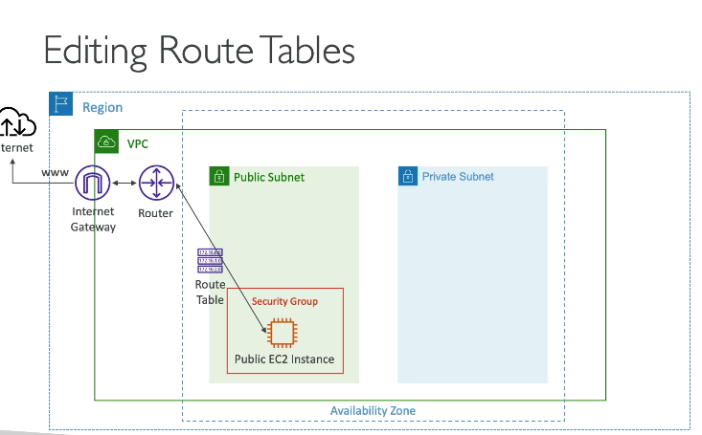
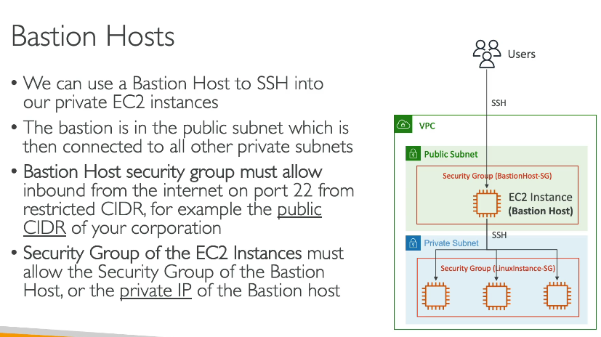

What is a Bastion Host?
A Bastion Host is a special-purpose server that acts as a secure gateway to access private instances in your VPC that don’t have public IPs.
Think of it as a "jump server".

🧱 Real-Life Analogy:
Imagine a high-security building (your private subnet).
Visitors can't enter directly — they must check in at a security desk (bastion host) before being escorted inside.

🏗️ When Do You Use a Bastion Host?
✅ You have:
- Private EC2 instances (no public IP)
- You need SSH access to them
- You want to keep them secure and not exposed to the internet

🔧 Setup Flow (with example):
Architecture:
vbnet
Internet
│
[Public Subnet]
│
[Bastion Host (EC2 with Public IP)]
│
[Private Subnet]
│
[Private EC2 (No Public IP)]
Steps:
- Launch EC2 (Bastion) in Public Subnet
  - Assign Elastic IP
  - Allow SSH (port 22) from your IP in the Security Group
- Launch private EC2 in Private Subnet
  - No public IP
  - Allow SSH only from the Bastion Host's private IP
- SSH Flow:
  - SSH to Bastion from your local system
  - Then SSH into the private EC2 using:
bash
ssh -i private-key.pem ec2-user@<private-ec2-private-ip>

🔐 Security Best Practices
Practice | Why it matters
Use key-based SSH | Avoid password-based logins
Restrict SSH to your IP range | Prevent open access to Bastion
Use IAM roles for Bastion | Avoid hardcoded credentials
Enable logging (CloudWatch) | Monitor who accessed what, and when
Use Session Manager (optional) | For SSH-less access to instances

🧠 Bonus: Bastion vs VPN?
Feature |  |  |  |  |  |  |  |  |  | Bastion Host |  |  |  |  |  |  |  | VPN
Simpler setup |  |  |  |  |  |  |  |  |  | ✅ Yes |  |  |  |  |  |  |  | ❌ More setup steps
Cost-effective |  |  |  |  |  |  |  |  |  | ✅ Yes |  |  |  |  |  |  |  | ❌ Usually more expensive
Security |  |  |  |  |  |  |  |  |  | Good (needs hardening) |  |  |  |  |  |  |  | Excellent (end-to-end encryption)
SSH only |  |  |  |  |  |  |  |  |  | ✅ Mostly used for SSH |  |  |  |  |  |  |  | ❌ Can support full network access

What is a NAT Instance?
NAT stands for Network Address Translation.
A NAT Instance is an EC2 instance configured to allow private subnet resources to access the internet (e.g., for software updates), while preventing inbound internet access to them.

💡 Real-Life Analogy:
Think of a NAT instance like a messenger window at a secure office. Employees (private EC2s) can send messages (requests) outside, but outsiders cannot message them directly back — all responses come through the messenger (NAT).

✅ When to Use a NAT Instance?
You need a NAT instance when:
- Your private subnet EC2s need to pull updates, reach external APIs, etc.
- You don't want to expose them with public IPs.

🔧 Setup Architecture:
css
Internet
│
[Internet Gateway]
│
[Public Subnet]
└── [NAT Instance (EC2)]
│
[Private Subnet]
└── [Private EC2s]

🛠️ Steps to Setup NAT Instance:
- Launch EC2 (Amazon Linux 2) in a Public Subnet
  - Enable Public IP
  - Choose an official NAT AMI or configure manually
  - Disable Source/Destination check
  - Create a Security Group that allows:
    - Inbound: From private subnet on required ports
    - Outbound: Anywhere (0.0.0.0/0)
- Configure Route Table for Private Subnet
  - Add route:
makefile
Destination: 0.0.0.0/0
Target: NAT instance ID
- Test
  - Launch a private EC2
  - Run curl google.com → should work via NAT

🔒 Security Tips
Setting | Why
Disable source/dest check | Required for NAT to work
Lock down SSH on NAT | Only allow your IP
Use IAM roles if needed | Avoid hardcoding keys
Monitor traffic via VPC Flow Logs | For auditing

What is a NAT Gateway?
A NAT Gateway (Network Address Translation Gateway) is an AWS-managed service that allows instances in a private subnet to connect to the internet, but prevents unsolicited inbound connections from the internet.
It's basically like a NAT Instance, but fully managed, highly available, and scalable.

🧠 Real-Life Analogy:
Imagine a secure receptionist (NAT Gateway) who sends your office documents (requests) to the outside world and brings back the responses — without letting outsiders in. 📬

🏗️ Use Case:
- Your EC2s in private subnet need to:
  - Install updates
  - Reach public APIs
  - Upload logs to S3
- You don’t want to assign public IPs to them.

🧰 Architecture:
css
Internet
│
[Internet Gateway]
│
[Public Subnet]
└── [NAT Gateway]
│
[Private Subnet]
└── [Private EC2 Instances]

🛠️ How to Set Up a NAT Gateway:
- Create NAT Gateway:
  - Place in a public subnet
  - Attach an Elastic IP (EIP)
- Modify Private Subnet Route Table:
  - Add a route:
makefile
Destination: 0.0.0.0/0
Target: NAT Gateway ID
- Test Internet Access:
  - From a private instance, run:
bash
curl google.com

🔐 Security Points
🔒 Component |  |  |  |  |  | Best Practice
Security Groups |  |  |  |  |  | Not needed (NAT Gateway doesn’t use them)
NACLs (Network ACLs) |  |  |  |  |  | Ensure egress rules allow traffic
Elastic IP |  |  |  |  |  | Must be attached to NAT Gateway

🆚 NAT Gateway vs NAT Instance
Feature | NAT Gateway | NAT Instance
Managed | ✅ Yes (AWS managed) | ❌ No (you manage it)
High Availability | ✅ Yes (across AZs) | ❌ No (single AZ unless custom HA)
Scaling | ✅ Auto scales | ❌ Manual (based on instance type)
Cost | 💰 Slightly higher | 💰 Lower for low-traffic setups
Setup Time | ⏱️ Very fast | 🛠️ More manual steps

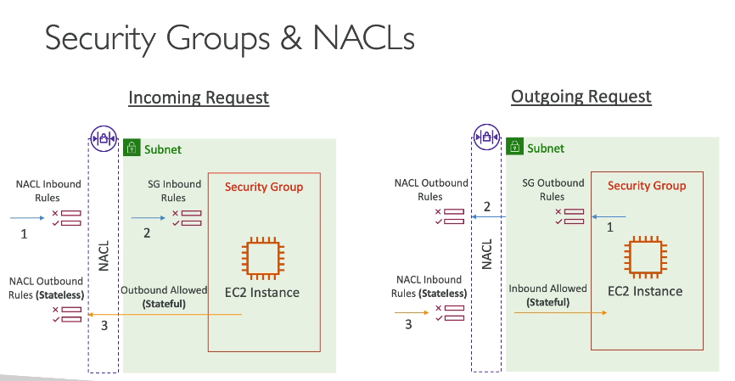
NACL vs Security Group in AWS
Both are network security layers in AWS, but they function differently and are applied at different levels.

🔰 Security Groups (SGs)
“Virtual Firewalls for EC2 instances”
📌 Key Points:
Feature | Description
Applies To | EC2 instances, ENIs
Stateful | ✅ Yes (return traffic is automatically allowed)
Rules Type | Only allow rules
Default Behavior | Deny all, allow only what you specify
Evaluation Order | All rules are evaluated together
🛠 Example:
- Allow inbound SSH from your IP:
yaml
Inbound Rule:
Type: SSH, Port: 22, Source: your-IP
- If allowed, return SSH traffic is automatically allowed (stateful).

🔐 NACL (Network ACL)
“Virtual Firewalls for Subnets”
📌 Key Points:
Feature | Description
Applies To | Entire subnets
Stateless | ❌ No (you must allow both inbound & outbound separately)
Rules Type | Can allow and deny traffic
Default Behaviour | Default NACL allows everything (both directions)
Evaluation Order | Uses Rule Number Order (lowest first)
🛠 Example:
To allow HTTP (port 80):
- Inbound rule:
nginx
Rule #: 100, Allow, Protocol: TCP, Port: 80, Source: 0.0.0.0/0
- Outbound rule (response):
Rule #: 100, Allow, Protocol: TCP, Port: 1024-65535, Destination: 0.0.0.0/0

⚖️ NACL vs Security Group — Quick Comparison
Feature |  |  |  |  |  |  |  | Security Group |  |  |  |  |  |  |  |  |  | NACL
Scope |  |  |  |  |  |  |  | EC2 / ENI |  |  |  |  |  |  |  |  |  | Subnet
Stateful |  |  |  |  |  |  |  | ✅ Yes |  |  |  |  |  |  |  |  |  | ❌ No (stateless)
Allow/Deny |  |  |  |  |  |  |  | Only Allow |  |  |  |  |  |  |  |  |  | Allow + Deny
Rule Evaluation |  |  |  |  |  |  |  | All rules evaluated |  |  |  |  |  |  |  |  |  | Evaluated by rule number
Default |  |  |  |  |  |  |  | Deny all |  |  |  |  |  |  |  |  |  | Allow all
Logging Support |  |  |  |  |  |  |  | ❌ Not directly |  |  |  |  |  |  |  |  |  | ✅ Via VPC Flow Logs

🔐 Real Life Analogy
- Security Group = Lock on the door of your room (instance-level)
- NACL = Security guard at the building gate (subnet-level)
You might allow someone into the building (NACL), but not into your room unless the door (SG) allows it too.
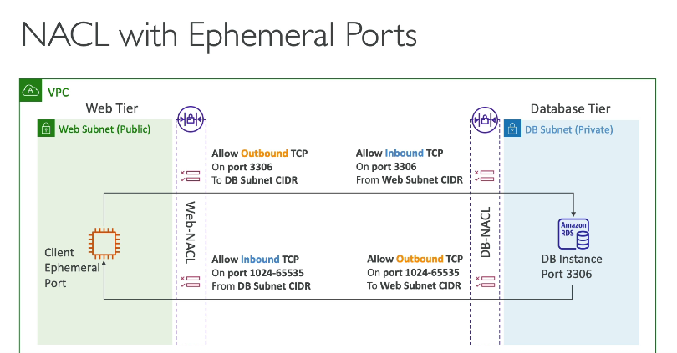

What is VPC Reachability Analyzer?
VPC Reachability Analyzer is an AWS tool that helps you check if two resources in your VPC can communicate with each other over the network.
It performs end-to-end connectivity analysis based on:
- Routing
- Network ACLs
- Security Groups
- VPC Peering
- Internet Gateway, NAT, etc.

💡 Why Use It?
Instead of manually checking SGs, NACLs, route tables, and firewalls, Reachability Analyzer simulates the network path and tells you:
- ✅ Reachable
- ❌ Unreachable (with reason why — e.g., SG blocked, route missing, etc.)

🧪 Example Use Case:
You're troubleshooting why a web server in Subnet A can’t talk to a database in Subnet B.
Instead of checking everything manually, just run:
yaml
CopyEdit
Reachability Analyzer: Source = Web EC2, Destination = DB EC2, Port = 3306
And it will tell you whether it’s reachable and where the issue lies if not.

🏗️ How It Works
- Go to VPC Console → Reachability Analyzer
- Create and run an analysis
- Choose:
  - Source resource (EC2, ENI, etc.)
  - Destination resource (EC2, ENI, Gateway, etc.)
  - Optional: Protocol/Port
- Click Analyze path
- View results:
  - ✅ Reachable
  - ❌ Unreachable (with detailed reason)

What is VPC Peering?
VPC Peering is a network connection between two VPCs that enables them to communicate privately using private IP addresses.
Think of it as a private bridge between two virtual networks.

✅ Use Cases
- Connect different environments (e.g., Dev VPC ↔ Prod VPC)
- Connect VPCs across AWS accounts
- Connect VPCs in different regions (called inter-region VPC peering)

🏗️ How it Works
Let’s say you have:
- VPC-A (10.0.0.0/16)
- VPC-B (192.168.0.0/16)
You create a peering connection between them, and after updating the route tables, instances in VPC-A can talk to instances in VPC-B using their private IPs.

⚙️ Steps to Set Up VPC Peering
- Create Peering Connection
  - Go to VPC Console → Peering Connections → Create
  - Select requester and accepter VPCs
- Accept the Connection
  - The other VPC owner/account accepts the request.
- Update Route Tables
  - Add routes in both VPCs to direct traffic through the peering connection.
- ✅ Check Security Groups/NACLs
  - Ensure they allow traffic between VPCs.

🔐 Key Rules and Limitations
Rule | Explanation
No transitive peering | VPC-A ↔ VPC-B and VPC-B ↔ VPC-C ≠ VPC-A ↔ VPC-C
Overlapping CIDR ranges not allowed | VPCs must have non-overlapping IP ranges
One-to-one connection | Each pair needs a separate peering link
Cross-account/region possible | Yes, just requires correct permissions and setup

Internet Gateway (IGW) vs NAT Gateway (NGW)
Feature | Internet Gateway (IGW) | NAT Gateway (NGW)
Purpose | Enables public internet access for public VMs | Allows private VMs to access the internet outbound only
Inbound Access | ✅ Supports inbound traffic (e.g., users accessing website) | ❌ Does NOT allow inbound connections
Outbound Access | ✅ Allows outbound traffic | ✅ Allows outbound traffic only
Used By | Public VMs (like your frontend NGINX) | Private VMs (like backend Django, MySQL updates)
Requires Public IP | ✅ Yes | ❌ No (private IPs only)
Routing | Route table points 0.0.0.0/0 to IGW | Private subnet routes 0.0.0.0/0 to NAT Gateway

💡 When to Use What?
Use Case |  |  |  |  |  |  |  |  |  | Use
Users accessing your ChatApp frontend via browser |  |  |  |  |  |  |  |  |  | Internet Gateway
Backend VM pulling updates from GitHub or pip install |  |  |  |  |  |  |  |  |  | NAT Gateway
MySQL server connecting to external repo for setup |  |  |  |  |  |  |  |  |  | NAT Gateway
Allowing users to access API hosted in public subnet |  |  |  |  |  |  |  |  |  | Internet Gateway

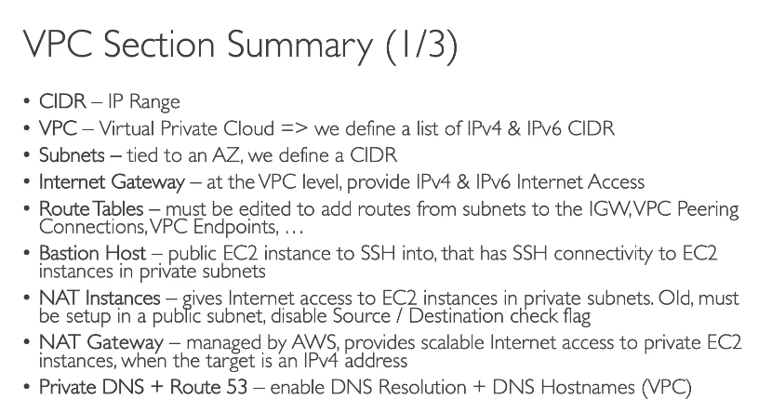
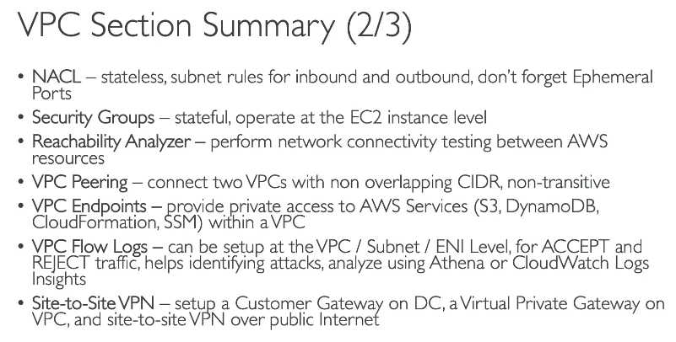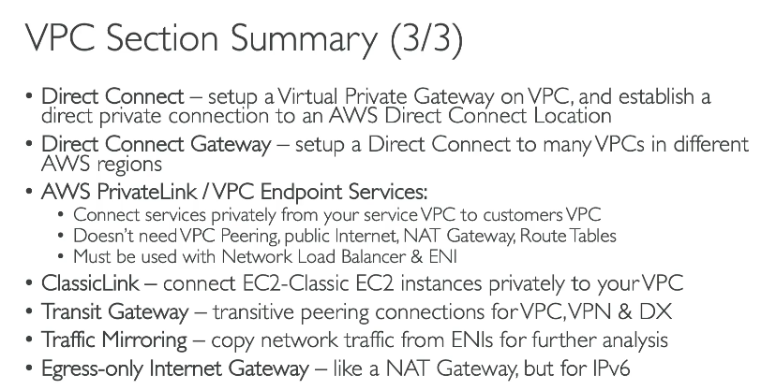
What is AWS Network Firewall?
AWS Network Firewall is a stateful, managed firewall service to help protect your VPC-level traffic.
It lets you define:
- ✅ Allow or block rules (IP, port, protocol)
- ✅ Domain name filtering (FQDN)
- ✅ Threat intelligence-based blocking (e.g., known malicious IPs)
It's like having a smart security guard at the entrance of your VPC.

🔐 Why Use It?
- Control inbound & outbound traffic
- Protect backend servers (like Django, DB)
- Stop malware or unauthorized communication
- Get centralized logging for threat monitoring

📦 ChatApp Use Case Example
You're deploying a multi-tier ChatApp with:
- Frontend (NGINX) — Public Subnet
- Backend (Django) — Private Subnet
- Database (MySQL) — Private Subnet
- NAT Gateway for private subnet to reach the internet
✅ You want to:
- Only allow ports 80/443 to frontend
- Allow backend to talk to DB only on port 3306
- Block backend from accessing unauthorized domains
- Detect suspicious traffic from compromised IPs
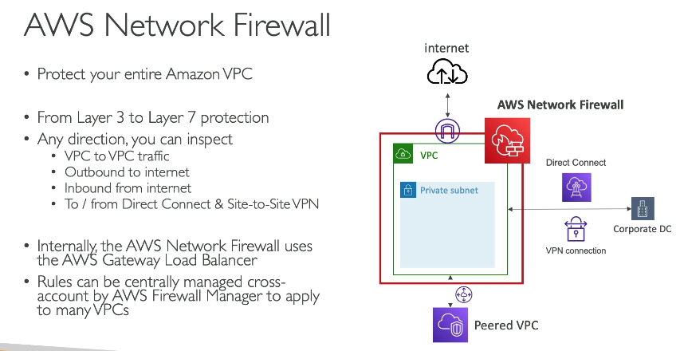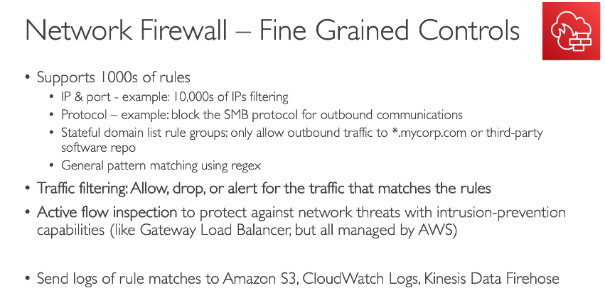

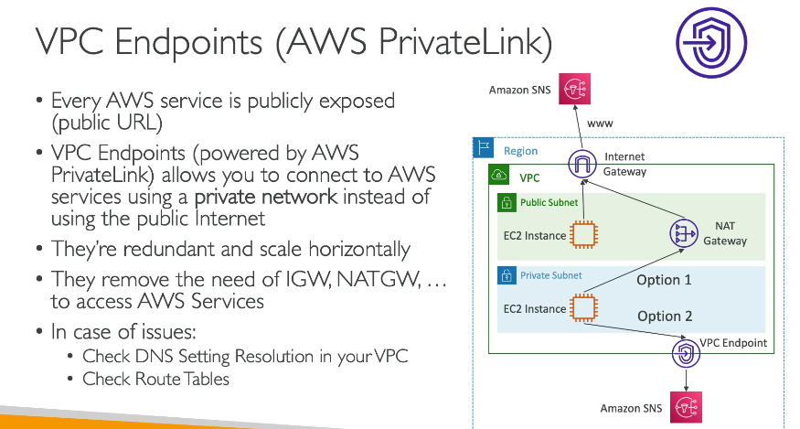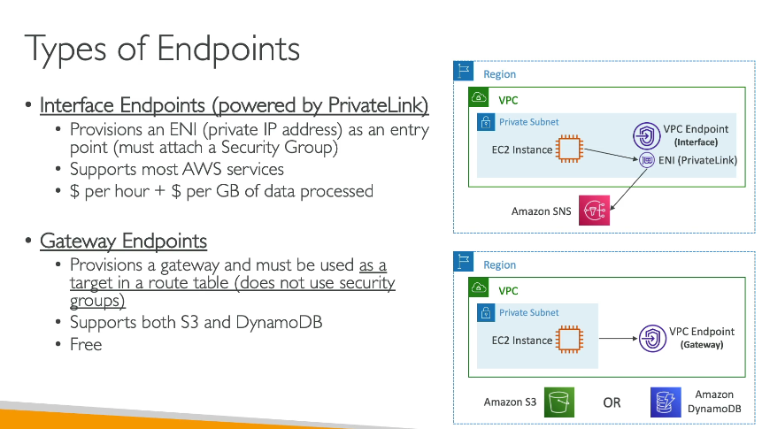

What is a VPC Endpoint?
A VPC Endpoint lets your resources in a VPC privately connect to AWS services without needing an Internet Gateway, NAT device, or VPN.
✅ Communication stays inside AWS private network
✅ No public internet exposure
✅ More secure, faster, and cheaper

🚀 Example: Your ChatApp Application
You have:
- Frontend (NGINX) VM in Public Subnet
- Backend (Django) VM in Private Subnet
- MySQL Database (on private VM)
- And maybe you're using S3 to store profile pictures or chat attachments 📸.

Problem:
- Your Django backend needs to upload/download files from an S3 bucket.
- But your backend VM is private (no Internet access via NAT or IGW).
- Without internet, it can’t reach S3!

Solution: Use a VPC Endpoint for S3
→ Now, your Django app can access S3 privately over AWS network.

🏗️ Flow with VPC Endpoint
Here’s how it looks visually:
User (Internet)
↓
Frontend (NGINX - Public Subnet - 20.x.x.x)
↓
Backend (Django - Private Subnet - 10.0.3.4)
↓
VPC Endpoint (for S3 service)
↓
S3 Bucket (e.g., s3://chatapp-profile-pics)
- Your private Django server hits the VPC Endpoint DNS,
- AWS routes that internally to S3 — no public internet required!

⚙️ How to Create VPC Endpoint for S3
- Go to VPC Console → Endpoints → Create Endpoint
- Service category: AWS services
- Service name: Find com.amazonaws.<region>.s3
- VPC: Select your VPC (where Django backend is)
- Subnets: Choose private subnets (where Django runs)
- Security group: Attach one allowing outbound traffic to S3 (port 443)
- ✅ Create!
AWS automatically creates private DNS names to access S3.

🔥 Real Example URLs:
When you use boto3 or SDKs inside Django, it will talk to:
arduino
CopyEdit
https://s3.<region>.amazonaws.com
But AWS automatically maps it to the VPC Endpoint → S3 Private → No public internet involved!

🧠 Types of VPC Endpoints
Type | Used For | Example
Gateway Endpoint | S3 and DynamoDB | 📂 S3 bucket access (your case)
Interface Endpoint | Most other AWS services (e.g., SSM, SNS) | 🔌 Connecting to services privately
👉 S3 uses Gateway Endpoints.

What are VPC Flow Logs?
VPC Flow Logs allow you to capture network traffic information about IP traffic going in and out of your VPC interfaces (ENIs — Elastic Network Interfaces).
✅ It records who talks to whom, when, how much data, and whether it was allowed or denied.

🛠 Why are Flow Logs useful?
Use Case | Purpose
Troubleshooting | Debug connection issues (e.g., Django can't reach DB)
Security analysis | Check for suspicious traffic
Compliance & auditing | Record network activity for reports
Performance monitoring | Analyze traffic bottlenecks

🏗️ Real Example — ChatApp Setup
You have:
- Frontend NGINX → Public Subnet
- Backend Django → Private Subnet
- MySQL → Private Subnet
- S3 → Accessed via VPC Endpoint
Now imagine:
- Backend can’t reach MySQL DB.
- You don't know if it's security group, NACL, route table, or network problem.
👉 Enable VPC Flow Logs to see exactly what is happening!
You’ll find logs like:
srcaddr | dstaddr | action | status
10.0.3.4 (backend) | 10.0.4.4 (DB) | ACCEPT | OK
10.0.3.4 (backend) | 1.2.3.4 (internet IP) | REJECT | NACL_DENY
You can immediately tell:
- Is the traffic allowed or rejected?
- Which IP is trying to reach whom?

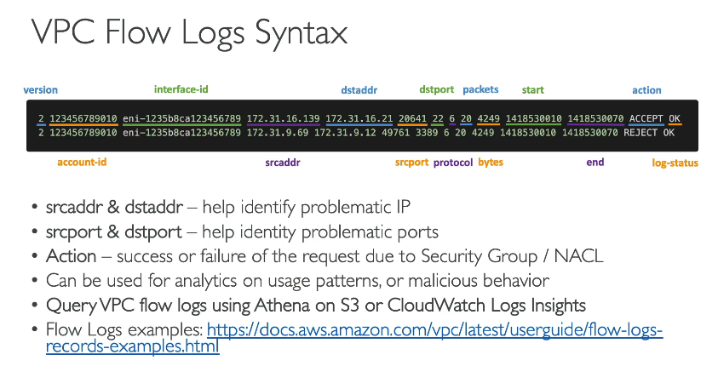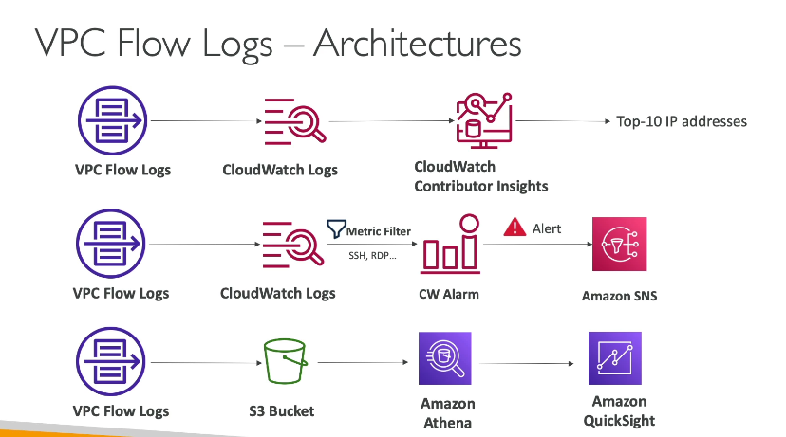
VPC Flow Logs — Architectures Explained
There are 3 main architectures shown here:

1️⃣ Flow 1: Analyzing Top 10 IPs
Flow:
Css

VPC Flow Logs → CloudWatch Logs → CloudWatch Contributor Insights → Top-10 IP Addresses
Explanation:
- VPC Flow Logs capture your network traffic.
- CloudWatch Logs stores the traffic logs.
- CloudWatch Contributor Insights analyzes logs automatically.
- It tells you things like:
  - Top 10 IP addresses making most connections.
  - Top talkers (senders/receivers).
  - Helps detect abnormal behavior (e.g., someone trying to flood your ChatApp backend).
✅ Use case:
Quickly find which IPs are using most of your network resources 📈.

2️⃣ Flow 2: Alerting for Sensitive Access (SSH, RDP)
Flow:
scss
VPC Flow Logs → CloudWatch Logs → Metric Filter → CloudWatch Alarm → Amazon SNS (Alert)
Explanation:
- VPC Flow Logs capture traffic.
- CloudWatch Logs stores the logs.
- Metric Filter watches logs for specific patterns like:
  - SSH (port 22)
  - RDP (port 3389)
- CloudWatch Alarm triggers if someone tries to access your servers via SSH or RDP.
- Amazon SNS sends you an email, SMS, or app notification immediately ⚡.
✅ Use case:
Someone trying unauthorized SSH/RDP to your backend → Instant alert → Action!

3️⃣ Flow 3: Deep Analysis via Athena + Visualization
Flow:
css
VPC Flow Logs → S3 Bucket → Amazon Athena → Amazon QuickSight
Explanation:
- VPC Flow Logs stored in an S3 bucket.
- Amazon Athena lets you run SQL queries directly on the logs in S3!
  - Example:
sql
SELECT srcaddr, dstaddr, COUNT(*) FROM flow_logs GROUP BY srcaddr, dstaddr
- Amazon QuickSight lets you create beautiful dashboards and graphs 🎨.
✅ Use case:
Want beautiful charts of traffic flow to your ChatApp backend?
✅ This is the best and scalable option.

🧠 Quick Memory Tip
Flow | Purpose
1. Contributor Insights | Top IPs
2. Metric Filters + Alarms + SNS | Instant alert for suspicious traffic
3. S3 + Athena + QuickSight | Full-scale SQL analysis and visualization

📦 Small ChatApp Example (Relating It to Your Project)
You want to... | You should use...
Find top IPs hitting your Django app | Contributor Insights
Get an alert if someone tries SSH on backend VMs | Metric Filter + Alarm + SNS
Create a dashboard showing all traffic patterns | S3 + Athena + QuickSight

What is a Site-to-Site VPN?
A Site-to-Site VPN connects two different networks over the internet securely, such as:
- Your on-premises data center or office
- To your AWS VPC (Virtual Private Cloud)
This lets both networks communicate as if they’re in the same local network — securely and privately.

🧱 Key Components
1️Customer Gateway (CGW)
- Represents your on-premise network (or another cloud VPC).
- Can be a physical router, firewall, or a virtual device.
- You define this on AWS with your external/public IP.
2️Virtual Private Gateway (VGW)
- AWS-side gateway attached to your VPC.
- It’s what accepts incoming VPN connections from outside.
3️VPN Connection
- The encrypted tunnel that connects CGW ↔ VGW.
- It uses IPsec (a security protocol).

📦 Small ChatApp Example – Real-World Use Case
Imagine you have:
- A backend ChatApp server (Django) running in AWS VPC.
- A MySQL database running in your on-premises office/data center.
You want the Django app to securely connect to the on-prem database without exposing the DB to the public internet.
💡 Solution: Use Site-to-Site VPN
Setup:
- Customer Gateway (CGW):
  - Create this in AWS using your on-premises router’s public IP.
- Virtual Private Gateway (VGW):
  - Create and attach it to your AWS VPC (where your Django app is hosted).
- VPN Connection:
  - Configure VPN on both ends:
    - AWS: Use the console.
    - On-prem: Use router/firewall (or software like pfSense, Cisco, etc.).
- Routing:
  - Update route tables in AWS VPC to send DB traffic to VGW.
  - Update routes on-prem to send AWS traffic via VPN.
✅ Result:
Your ChatApp (in AWS) can talk to your on-prem MySQL database securely and privately.
No need to expose your DB to the internet.

🔐 Security Advantages
- Data is encrypted end-to-end.
- You don’t expose your internal resources.
- You control all routing and access via security groups and firewalls.

🧠 Quick Summary Table
Term | Meaning | In ChatApp Example
Customer Gateway (CGW) | Your on-premises network’s device | Your data center with MySQL DB
Virtual Private Gateway (VGW) | AWS-side entry point into your VPC | AWS VPC where Django ChatApp runs
VPN Connection | Encrypted tunnel between CGW and VGW | Django app connects securely to DB
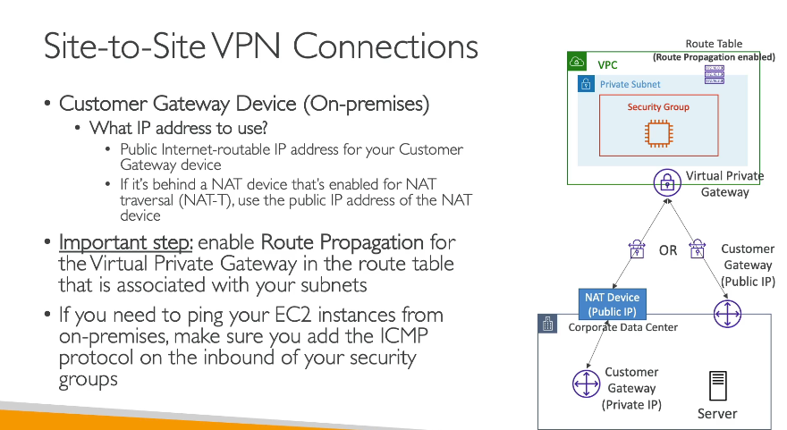

What is AWS Direct Connect?
AWS Direct Connect (DX) is a dedicated, private network connection between your on-premises data center and AWS.
Unlike VPN over the internet, Direct Connect bypasses the internet entirely, giving you:
- Lower latency
- Higher, more consistent bandwidth
- More secure and stable connection
🧱 What is Direct Connect Gateway?
Direct Connect Gateway (DX Gateway) lets you connect one Direct Connect to multiple VPCs, even across different AWS Regions.
It enables global access from one Direct Connect link.
🔁 Key Differences
Feature | Direct Connect | Direct Connect Gateway
Connects to AWS via | Private fiber | Connects to multiple VPCs
Region restriction | Single region | Cross-region / Global VPC access
Use case | One-to-one | One-to-many VPCs

📦 ChatApp Example – Real-World Use Case
Let’s say:
- You have a ChatApp backend in 3 AWS VPCs (India, US, Europe).
- Your central MySQL DB is in your on-premises data center.
✅ Your Goals:
- ChatApp backend in all regions should talk to on-prem DB.
- You want fast, secure, and low-latency communication.

💡 Solution: Use Direct Connect + Direct Connect Gateway
Setup:
- Create Direct Connect between your data center and AWS (e.g., in Mumbai).
- Create Direct Connect Gateway in AWS.
- Attach multiple VPCs (India, US, Europe) to this DX Gateway.
- Setup routes so all VPCs know how to reach your on-prem DB.
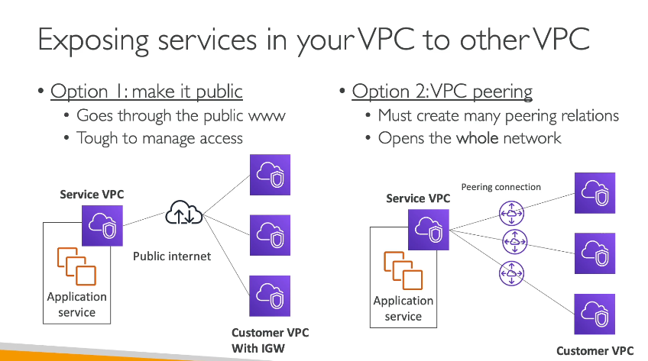

What is AWS PrivateLink?
AWS PrivateLink allows you to privately access services (like APIs, databases, apps) hosted in another VPC — without ever using the public internet.
It's a highly secure, private communication path between VPCs or between a VPC and AWS services.

🧩 Key Concepts
Term | Meaning
VPC Endpoint | Entry point for PrivateLink into your VPC
VPC Endpoint Service | A service that you create and expose privately to other VPCs
Interface Endpoint | An ENI (Elastic Network Interface) in your subnet that connects to the service

📦 ChatApp Use Case – Real-World Example
Let’s say you have this setup:
- Team A manages the ChatApp backend API in VPC A.
- Team B is building frontend or analytics tools in VPC B and needs to call the backend API.
❌ Problem:
- You don’t want to expose the backend API to the internet.

✅ Solution: Use AWS PrivateLink
- Team A creates a VPC Endpoint Service from the ChatApp backend.
- Team B creates an Interface Endpoint in their VPC to connect to it privately.
- All traffic stays within AWS private network — never hits the public internet.
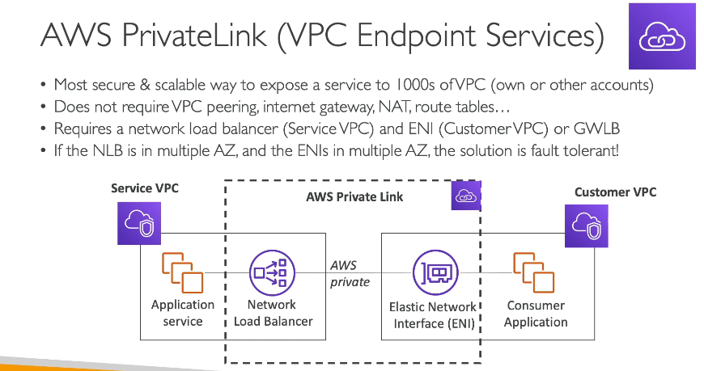

What is AWS Transit Gateway (TGW)?
AWS Transit Gateway is a central hub that connects multiple VPCs, on-prem data centers, and VPNs using a single gateway.
Think of it like a network switchboard for your cloud infrastructure:
Instead of creating many peering connections, you connect everything to one TGW.
💡 Why Use It?
Without TGW:
You'd need many VPC peering connections, which becomes messy and hard to scale.
With TGW:
You connect each VPC only once to the Transit Gateway — and you're done!

🔗 Key Benefits
Feature | Benefit
Scalable Networking | Connect 1000s of VPCs easily
Simplified Architecture | Centralized route management
Inter-Region Support | Connect VPCs across regions via peering
Hybrid Networking | Connect VPCs + VPN + Direct Connect in one place

📦 ChatApp Use Case – Real-World Example
- Your ChatApp backend is split into three VPCs:
  - India region (user API)
  - US region (chat server)
  - Europe region (file upload & storage)
- You also have an on-prem database that all regions should talk to.
✅ Your Goal:
- Make all regions talk to each other privately, and also to your on-prem DB.

✅ Solution: Use Transit Gateway
- Create a Transit Gateway in AWS.
- Attach all your VPCs and VPN (on-prem) to the TGW.
- TGW handles all routing and communication centrally.
When you create a subnet with CIDR 10.0.0.0/24 in AWS, 5 IP addresses are reserved and cannot be used by EC2 instances or other resources.
✅ The 5 reserved IPs in any AWS subnet are:
IP Address Purpose
10.0.0.0 Network address (first IP of the subnet)
10.0.0.1 Reserved by AWS for VPC router
10.0.0.2 Reserved by AWS for DNS (if enabled)
10.0.0.3 Reserved by AWS for future use
10.0.0.255 Broadcast address (last IP in the subnet)

❌ So the correct answer to your question is:
The following IP addresses are reserved EXCEPT:
✅ 10.0.0.4
👉 10.0.0.4 is NOT reserved and can be assigned to an EC2 instance or resource.

To connect your corporate network (10.0.0.0/8) and satellite office (192.168.0.0/16) to an AWS VPC (via VPN, Direct Connect, or Transit Gateway), your AWS VPC CIDR must not overlap with either of these existing CIDRs.

🔎 Given:
Corporate Network: 10.0.0.0/8 → All addresses from 10.0.0.0 to 10.255.255.255

Satellite Office: 192.168.0.0/16 → All addresses from 192.168.0.0 to 192.168.255.255

✅ Valid VPC CIDR examples (must not overlap with above):
Valid CIDR Reason
172.16.0.0/16 It’s in private range and not overlapping
172.31.0.0/16 Also private, and safe
100.64.0.0/16 Carrier-grade NAT, if compatible

AWS reserves 5 IP addresses in every subnet (network address, router, DNS, future use, broadcast).
So, the total IPs in your subnet must be at least:

28 (needed) + 5 (reserved) = 33 IP addresses

📐 Let's calculate the subnet size:
CIDR Block Total IPs Usable IPs (Total - 5)
/27 (e.g. 10.0.0.0/27) 32 27 usable ❌ Too small
/26 (e.g. 10.0.0.0/26) 64 59 usable ✅ Enough
/25 128 123 usable ✅ Overkill

✅ Correct Answer:
/26 subnet (e.g., 10.0.0.0/26)
✅ Gives 64 total IPs → 59 usable
✅ Supports 28 EC2 instances comfortably

